NAME:Haseeb Chattha
SAP:70136897
ASSIGNMENT 04 SOFTWARE ENGINEERING
Here’s a similar write-up tailored for a Library Management System project:

Project Title: Library Management System
Brief Introduction
This project involves designing and implementing a Library Management System to streamline library operations. The system allows members to search for books, borrow and return them, and view their borrowing history. It also provides librarians with tools to manage book inventory, member records, and overdue fines. The system is designed to improve efficiency, reduce manual effort, and enhance user experience with a simple and intuitive interface.
UML Diagrams
- Use Case Diagram: Captures the interactions between members, librarians, and the system, highlighting functionalities like searching for books, borrowing, and returning.
- Sequence Diagram: Depicts the step-by-step flow of actions during key processes, such as borrowing a book or managing member records.
- Class Diagram: Represents the static structure of the system, showcasing classes like Member, Book, Librarian, and their relationships.
Tool Used
The UML diagrams for this project were created using Lucidchart, a user-friendly online diagramming tool that supports collaborative editing and export to various formats like PNG and PDF.
1.USE CASE DIAGRAM
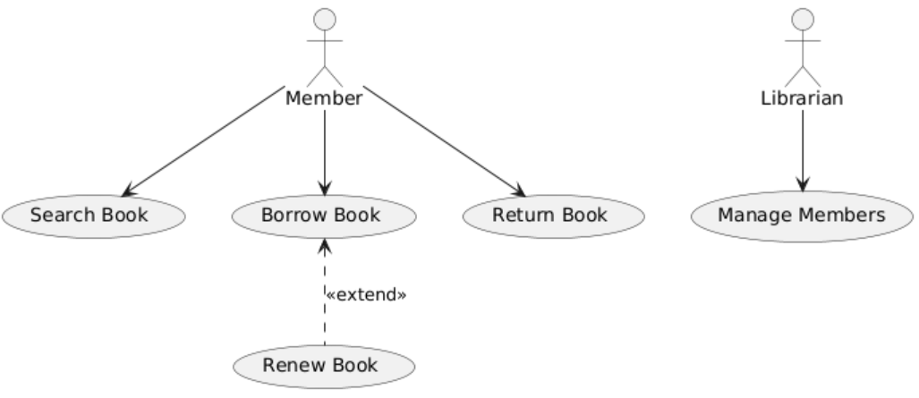
2.CLASS DIAGRAM
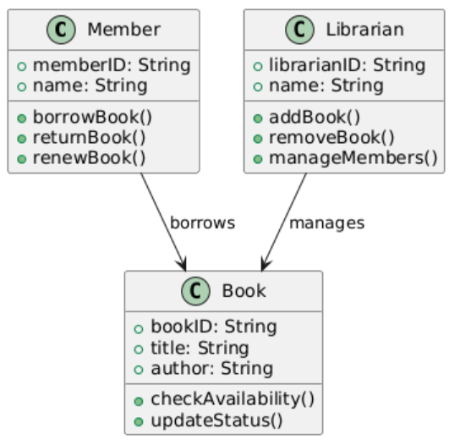
3.SEQUENCE DIAGRAM
